

American International University-Bangladesh (AIUB)  
**Department of Computer Science  
Faculty of Science & Technology (FST)**

**PROJECT TITLE**

**Automated Agriculture System: Create a system that uses AI and sensors to monitor and manage agricultural data.**

A Software Engineering Project Submitted

By

|  |  |  |  |  |
| --- | --- | --- | --- | --- |
| **Semester: Summer_21_22** | | **Section:** | **Group Number:** | |
| SN | Student Name | Student ID | Contribution (CO1+CO2) | Individual Marks |
| 01 | KHONDOKER MD. SABIT HASAN | 21-45306-2 |  |  |
| 02 | NOKIBUL ARFIN SIAM | 21-44793-1 |  |  |
| 03 | ABU NASER MD. ARMAN | 21-45239-2 |  |  |
| 04 | FAHIM RAHMAN | 21-44399-1 |  |  |
| 05 | MD. NAJIB HOSSAIN | 21-45366-2 |  |  |

The project will be Evaluated for the following Course Outcomes

|  |  |  |
| --- | --- | --- |
| CO1: *Analyze* the impact of software engineering models over various context of software development to assess societal, health, safety, legal and cultural issues. | Total Marks | |
|  | |
| Project Background Analysis and feasibility (needs, goal, benefits, etc.) | [5 Marks] |  |
| Analysis the impact of societal, health, safety, legal and cultural issues | [5Marks] |  |
| Review of existing Studies and Relevant Example | [5Marks] |  |
| CO2: *Explain* appropriate software engineering model, project management roles and their skills in the context of professional engineering practice and solutions to complex engineering problems in a software development environment. | Total Marks | |
|  | |
| Appropriate Process Model Selection and Argumentation with Evidence | [5Marks] |  |
| Evidence of Argumentation regarding process model selection | [5Marks] |  |
| Submission, Defense, Completeness, Spelling, grammar and Organization of the Project report | [5Marks] |  |

**contents**

|  |  |  |
| --- | --- | --- |
| **1** | **Project Proposal** …………………………………………………………………… | **3** |
|  | 1.1 Background to the problem ...……………………………………………………. | 3 |
|  | 1.2 Solution to the problem ..………………………………………………………… | 3 |
| **2** | **Functional Requirements** ………………………………………………………….. | **5** |
| **3** | **Diagrams** ……………………………………………………………………………. | **7** |
|  | 3.1 Use case diagram ……………………………………………………………….. | 7 |
|  | 3.2 Class diagram ………………………………………………………………….... | 8 |
|  | 3.3 Activity diagram ………………………………………………………………… |  |
|  | 3.4 Sequence diagram ……………………………………………………………….. |  |
|  |  |  |
|  |  |  |
|  |  |  |
|  |  |  |
|  |  |  |
|  |  |  |
|  |  |  |
|  |  |  |
|  |  |  |
|  |  |  |
|  |  |  |
|  |  |  |
|  |  |  |
|  |  |  |
|  |  |  |
|  |  |  |
|  |  |  |
|  |  |  |
|  |  |  |
|  |  |  |
|  |  |  |
|  |  |  |
|  |  |  |
|  |  |  |
|  |  |  |
|  |  |  |

# PROJECT PROPOSAL

**1.1 Background to the problem:**

Agriculture is the primary source of livelihood for millions of people worldwide. Efficient irrigation practices can help ensure the long-term viability of farming and support rural communities. In traditional irrigation methods, farmers often rely on manual observations and subjective judgment to determine when and how much to water their crops. This method can be time-consuming and labor-intensive and may result in inconsistent irrigation practices. Furthermore, the increasing demand for food production and the growing scarcity of water resources make it imperative to adopt more efficient irrigation techniques.

**1.2 Solution to the problem:**

An automated Agriculture System is a solution aimed at improving the efficiency and productivity of agriculture by automating the irrigation process. This system utilizes data on soil moisture levels and weather conditions to determine the optimal water required for each crop. This helps farmers conserve water resources and avoid over-irrigation, leading to soil degradation and reduced crop yields. The Automated Agriculture System provides solutions to these problems using sensors and weather monitoring technology to collect data on soil moisture levels and weather conditions. This information will determine the optimal amount of water required for each crop and automate the irrigation process. The system can also be programmed to consider crop type, soil type, and local weather patterns to optimize irrigation schedules. By automating the irrigation process, the Automated Agriculture System helps farmers to improve their yields, conserve water resources, and reduce labor costs. Some auto-irrigation software exists, but they don't check weather conditions. However, our software will take the weather information and make decisions based on the information that shows how much water is needed. Also, our study has utilized that the existing studies of irrigation process are too costly. Additionally, our study has focused on developing a scalable and purchasable cost solution for automated agriculture, making it accessible for smallscale farmers and agriculture firms. Furthermore, our study has emphasized incorporating realtime data analysis and visualization to help farmers make informed decisions regarding irrigation. This makes our study a significant contribution to the field of automated agriculture systems for irrigation. The target users for the "Automated Agriculture System that automates and controls the irrigation of crops based on soil moisture levels and weather conditions" are farmers and agricultural firms. This system is a step towards sustainable agriculture and helps to ensure the long-term viability of farming as a profession.

# FUNCTIONAL REQUIREMENTS

1. **Sing up**
   1. User registration form will allow users to create an account on the app by entering their name, username, email, and password.
   2. Email verification process to confirm the validity of the email address.
   3. Username & Password, which will be used to log into the site.
   4. Option to log in using a social media account (e.g., Facebook, Google).
2. **Software Login**

2.1 The software will allow users to log in with their username and password.

2.2 The login credentials (username and password) will be verified with database records.

2.3 If the login is successful, the user account's home page will be displayed.

2.4 If the username and/or password has been inserted wrong, the random verification

code the system will generate and send the user’s email address to retry login.

2.5 If the number of login attempt exceed its limit (3 times), the system shall block the

user account login for one hour [optional function]

1. **Weather forecast**
   1. The app will display the current weather conditions for the user's preferred location, including temperature, humidity, the possibility of rain, and wind speed. The information will be updated in real-time to provide the most accurate and up-to-date information.
   2. Option to view the 7-day forecast, including high and low temperatures and weather conditions. This will help users plan for the week ahead and prepare for adverse weather conditions.
   3. Ability to change the location to view weather forecasts for different cities.
2. **Settings**
   1. Location: Ability to set a preferred location to view weather forecasts.
   2. Language: Option to select a preferred language for the app.
   3. Profile: Ability to view and edit personal information, such as name and email address. This will allow them to keep their knowledge up to date.
   4. Password: Ability to change the old password.
3. **Community Feedback**
   1. Ability for users to provide feedback on the app, including suggestions for improvement.
   2. Option for users to rate the app and leave reviews.
   3. Ability for the developers to respond to user feedback and address any concerns. This will help build trust with users and demonstrate the developers' commitment to improving the app.
4. **Check soil moisture**
   1. The app will allow users to check the moisture levels in their soil. This is useful for farmers to monitor the health of their crops and ensure they are getting the water they need.
   2. To provide the most accurate readings, the app will allow users to select their preferred soil type. This will consider the different moisture requirements of different kinds of soil.
   3. Ability to view historical data on soil moisture levels.
5. **Notifications**
   1. Option to receive notifications for important events, such as changes in weather alerts or reminders to check soil moisture.
   2. Gives notification for agriculture articles, news, etc.
   3. Gives notification if helpline or support center responds.
6. **Helpline**
   1. Access a helpline or support center for assistance with any issues or questions.
   2. Option to contact support via email or phone.
   3. FAQs: The app will have a section with frequently asked questions and answers to help users find the information they need quickly and easily.
7. **Irrigation system setting**
   1. Auto On/Off: The app will be able to turn the irrigation system on and off automatically, based on pre-defined settings such as weather conditions or soil moisture levels.
   2. Manual On/Off: The user can manually operate (On/Off) the irrigation system.
   3. Set Timer: Ability to set a timer for the irrigation system to turn on and off.
   4. Set Water Level: Option to set a preferred water level for the irrigation system.

# DIAGRAMS

**3.1: Use Case Diagram**

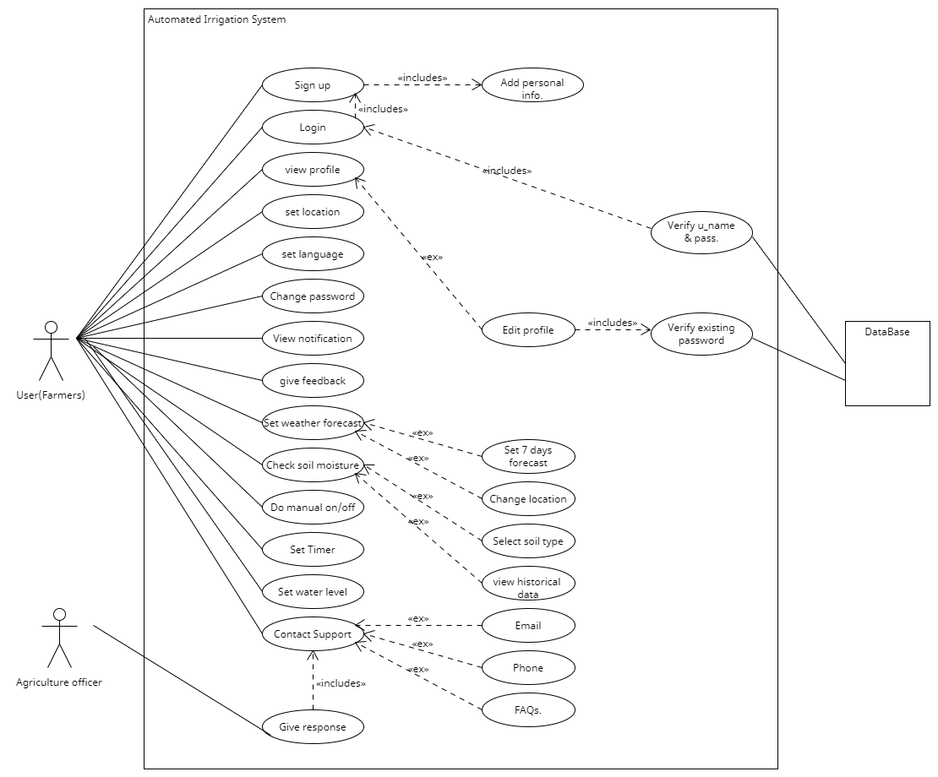

**3.2: Class Diagram**

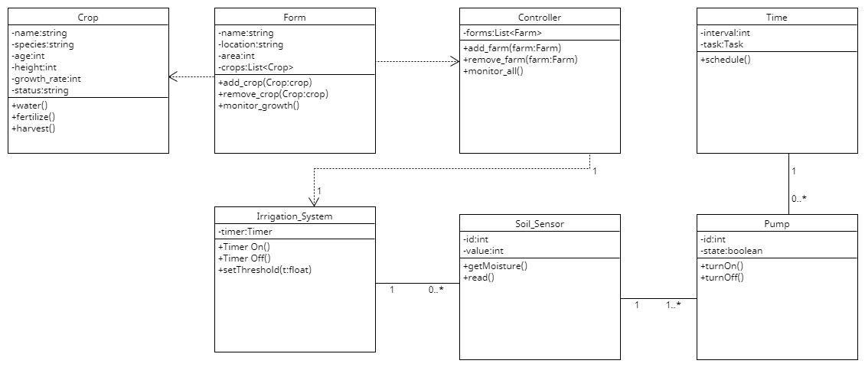

**3.3: Activity Diagram**

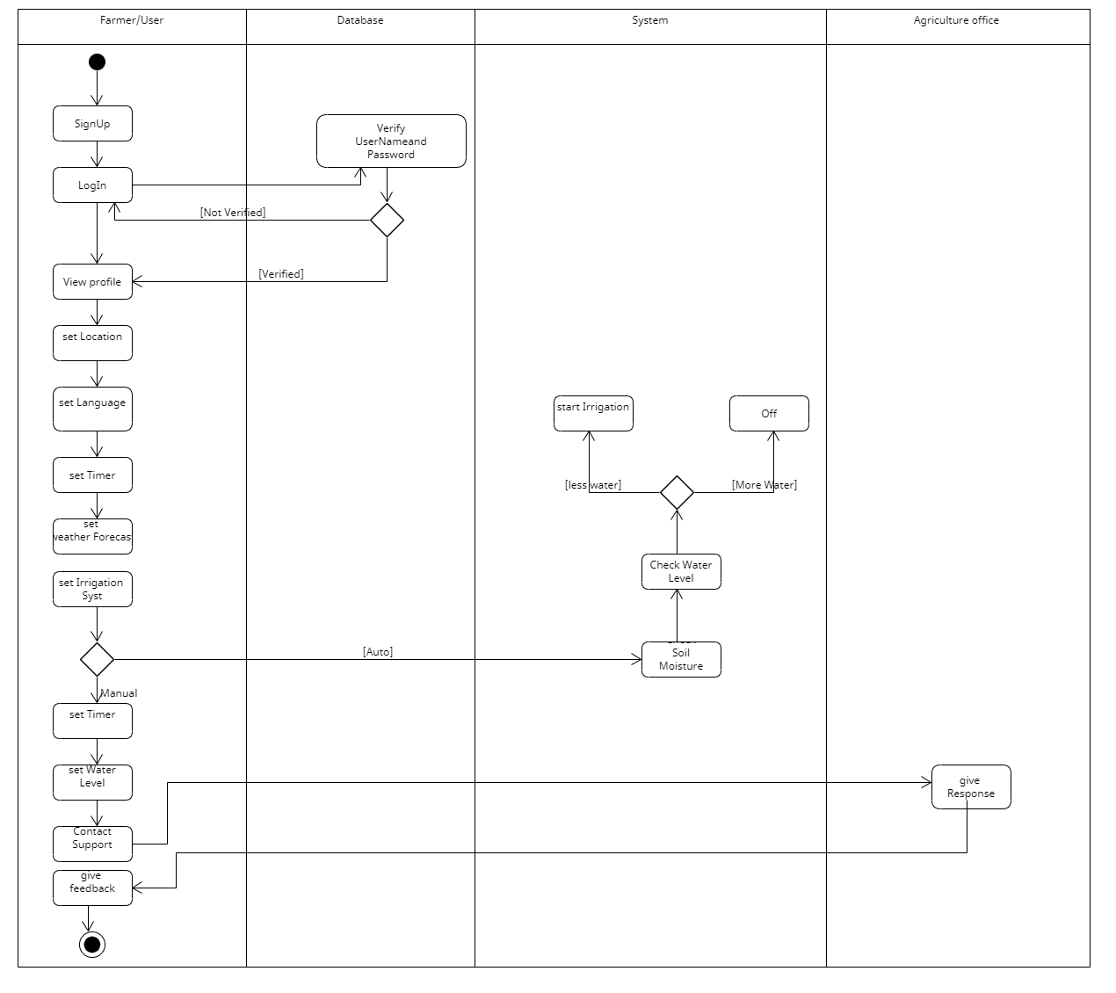

**3.4 Sequence Diagram**

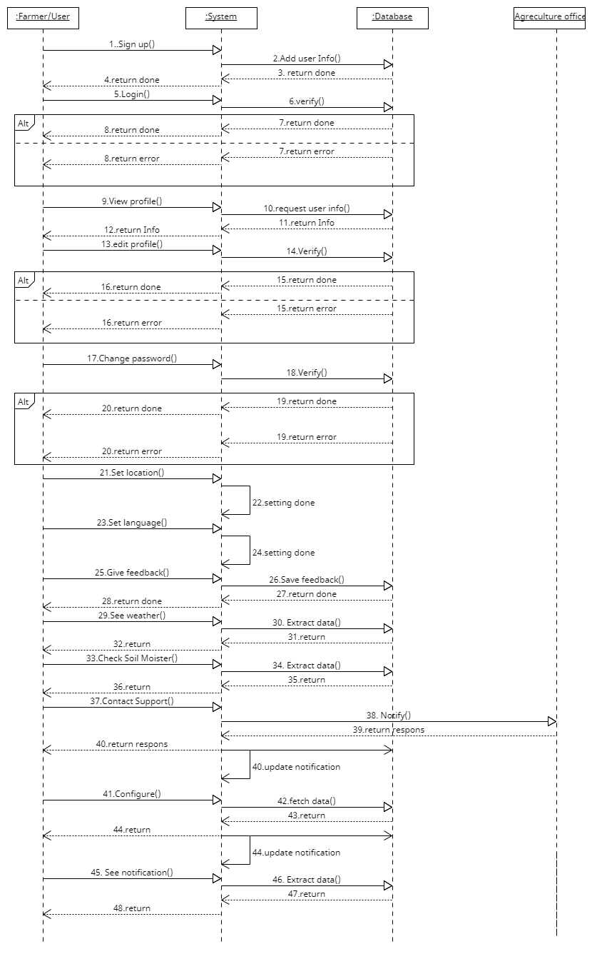

**Which model applied?**

For an Automated Agriculture System that automates and controls the irrigation of crops based on soil moisture levels and weather conditions, the software engineering model that is best suited is the Agile Model.

The Agile Model is a software development approach that is iterative and flexible, allowing for changes to be made quickly and efficiently as requirements and specifications change. This model is particularly well-suited for projects where requirements are likely to change frequently, such as in an agricultural system that relies on real-time weather data and soil moisture levels.

In an Agile development process, the development team works in short iterations, typically lasting a few weeks, to deliver working software that meets the changing needs of the system. The development process is collaborative, with frequent communication between the development team and stakeholders, ensuring that the system remains aligned with the needs of the business.

By adopting an Agile development process, the Automated Agriculture System can be built in a flexible and responsive way, allowing for changes to be made quickly and efficiently as the system evolves. This will ensure that the system remains effective and efficient, providing optimal irrigation to crops based on real-time data, and ultimately improving crop yields and reducing water waste.

**Which Agile model?**

There are several Agile models, each with its own specific characteristics and methodologies. However, for an Automated Agriculture System that automates and controls the irrigation of crops based on soil moisture levels and weather conditions, the Scrum model would be a good fit.

Scrum is an Agile model that focuses on delivering working software in short iterations called sprints. The development process is broken down into smaller, manageable tasks called user stories, and each sprint involves selecting a set of user stories to work on, completing them, and delivering a working product increment.

In the case of an Automated Agriculture System, each sprint could focus on adding new features or improving existing functionality, such as integrating new weather sensors or improving the system's ability to analyze soil moisture data. The product owner, who represents the stakeholders and is responsible for defining the system requirements, would work closely with the development team to prioritize user stories and ensure that the system is aligned with the needs of the business.

Scrum also emphasizes frequent communication and collaboration between the development team and stakeholders, with daily stand-up meetings and regular sprint reviews and retrospectives. This ensures that the system remains aligned with the needs of the business and that any issues or concerns are addressed quickly.

Overall, the Scrum model would be a good fit for an Automated Agriculture System as it provides a flexible and responsive development process that can adapt to changing requirements and priorities, while also ensuring that the system is delivered in working increments that provide real value to the business.